1. Summarize chapters from 6.4 to 6.5 in the text book.

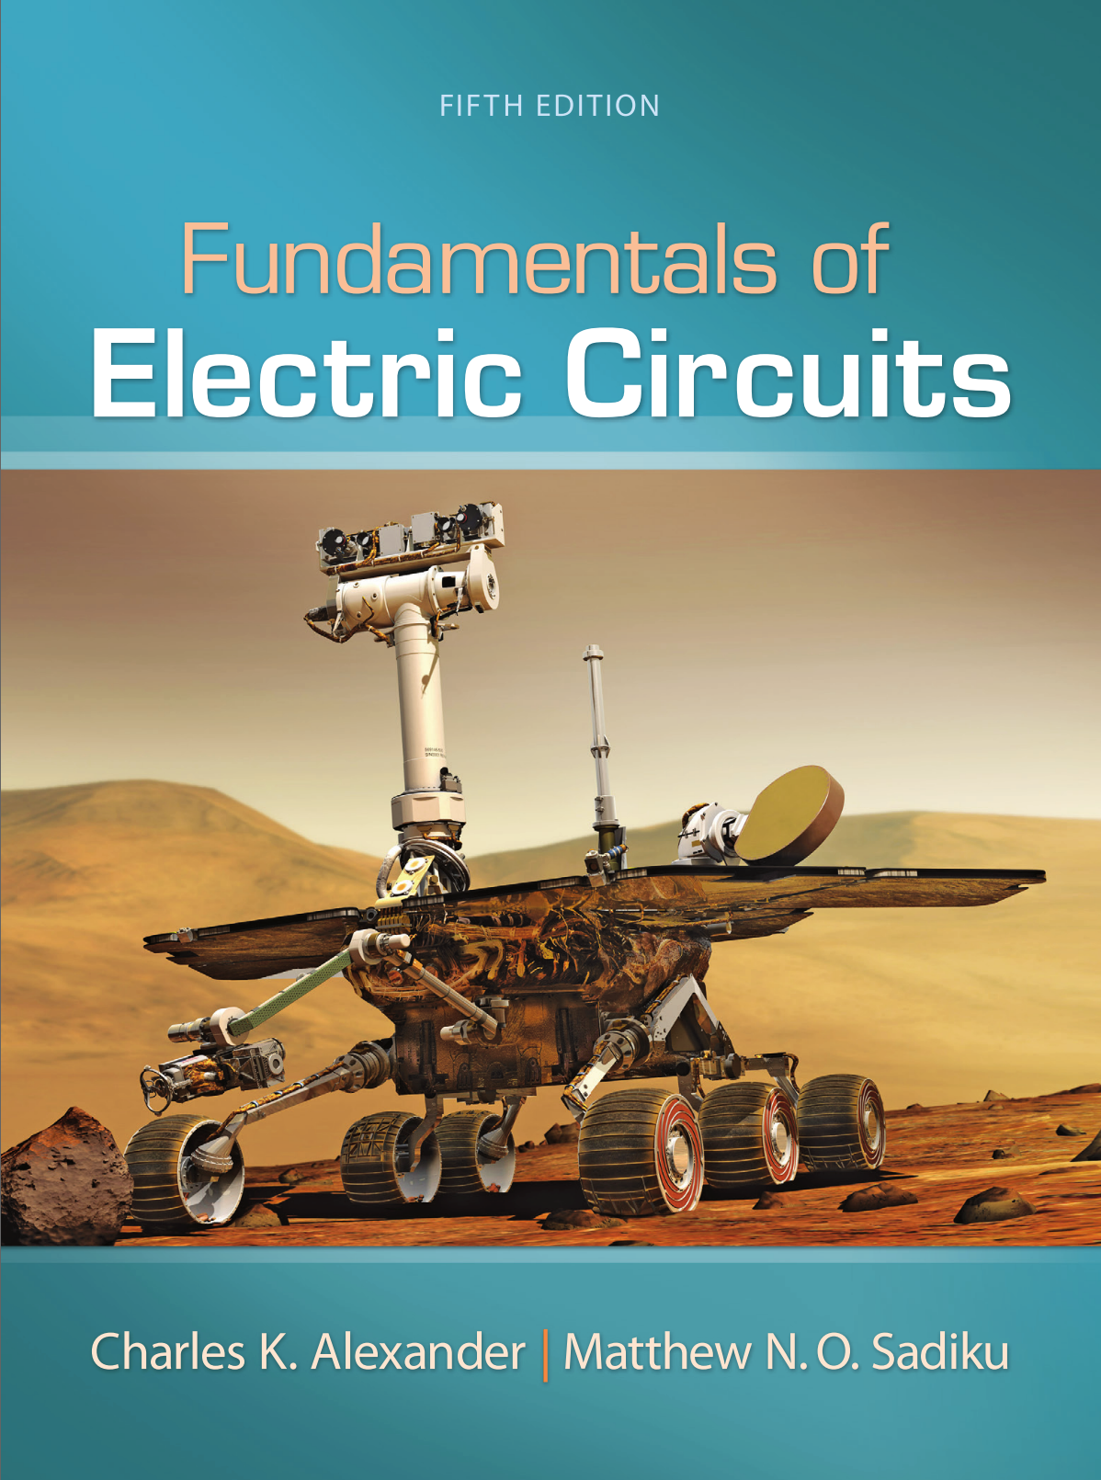

1. Please describe the solution of the examples in each chapter by handwriting. And take a picture of the solutions and attach the picture to the assignment file.